3D Scanner and 3D Printer Lab Instructions
Contents and Unboxing:
This kit contains two containers; the large Pelican case houses the 3D printer. This will require two people to lift it out. Once it’s out and on a flat sturdy surface you will have to remove some support brackets. To remove the first support bracket open the front door and locate the orange support bracket under the platform. Remove the thumb screw holding the bracket in place and remove the support bracket. Please place the thumb screw back in the hole so it doesn’t get lost. Open the lid on top of the 3D printer and remove the orange support bracket clipped on to the metal guide bars.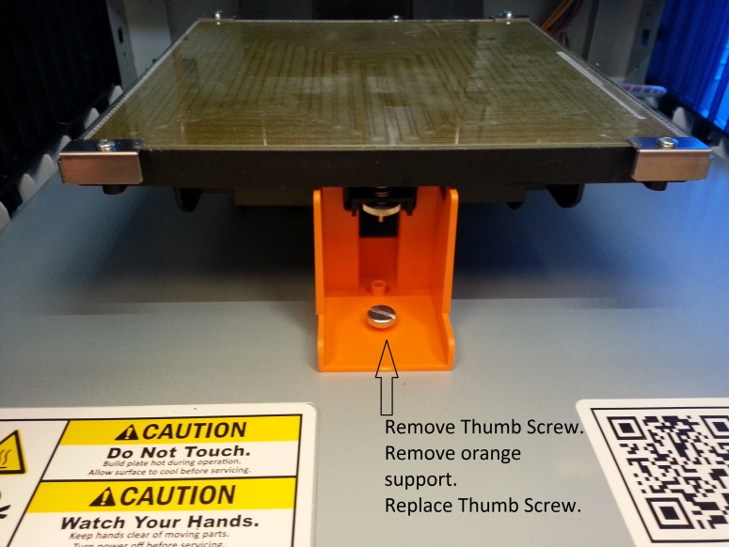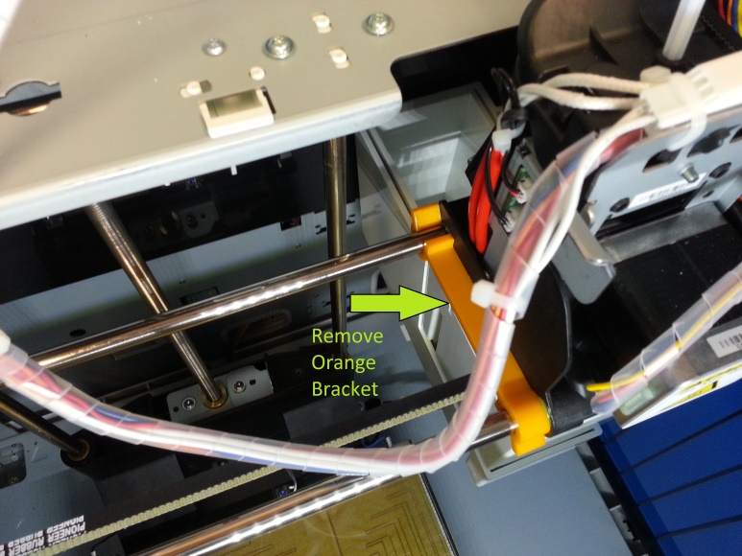
The kit also has a smaller Pelican case that contains the 3D scanner attached to an iPad. The kit also has a laptop with software for both the 3D Printer and Scanner.

Connections:
Connect the 3D Printer to the laptop insert the included USB cable to the back left side of the printer and the other end into a USB port on the laptop. Connect the power to the, the power cable connects to the lower rear left side of the printer.
The 3D scanner is in a smaller Pelican case already connected to the iPad.
The laptop included is like any other SCLS kit laptop in that it is protected with DeepFreeze meaning any projects that you want to save must be saved to an external form of media (Dropbox, USB flash drive). The laptop contains software for both 3D Scanning “Skanect” and 3D Printing “XYZware”.
Connect the 3D Scanner to the laptop turn on the laptop and double click the Connect 3D Scanner icon and in a few seconds the ad-hoc network will be setup to connect the iPad to the laptop. Open the Skanect 3D Scanner Software icon on the desktop. Click the Record tab. On the iPad tap the Settings icon and select Wi-Fi near the bottom of the right hand column under Devices should be 3D Scanner. Select that device and tap “Join Anyway” to the message that pops up. Touch the home button on the iPad to get back to the main screen and tap the “Structure” icon. If you get the “Please connect Structure Sensor” gently disconnect the white cable in the lightning plug and reconnect it. Tap the Uplink option to establish the connection with the laptop. You may get the message “Uplink failed to connect to Skanect.” If you receive this message tap “OK” and try it again. If it continues to fail go through these steps again.

Using the 3D Printer:
After the printer is unpacked and plugged in it’s time to go over a few things that need to be done before printing can start. One thing to keep in mind is that it takes about 5 to 10 minutes for the printer to warm up and calibrate before you can print. Also after your model is done printing it will take between 10 and 15 minutes for the print bed to cool off and lower so you can remove the finished printed object. Depending on the size and quality of your object it could take anywhere from 20 minutes to several hours to print an object. You should plan these times into your program or make the program a two part series spanning two days.
Powering on the Printer
Power on the printer by toggling the switch on the lower rear left side of the printer. After you’ve removed the orange clips securing the printer, you can load the filament, if it’s not already, before starting to print.
Cleaning the platform
Clean the glass surface of the platform by laying a damp paper towel on the platform for 5 minutes and then wiping in a circular motion, and then let it air dry for a few minutes before applying a light layer of glue over the surface of the platform using the glue stick provided.

Printing an object
Open the XYZware program on the desktop of the laptop provided in the kit. Close the little ad that appears. Open the file you want to print by clicking on the downward pointing arrow on the menu bar. You can make some adjustments to the size of the object you want to print now. Click the print icon on the menu bar when you’ve got the object the way you like it. You will be presented with some options. The first is what kind of quality you want. Default is “Good”, if you want the object to print faster select “Normal” and for a more solid object click “Excellent”, this option will take much longer to print. Material should stay the default of “ABS”. If your object has parts that overhang you can select supports and that will keep the parts that overhang in place. Click print on the upper left hand side of the window and the process will start.
After the object has printed the printer will take several minutes to cool down, when the platform lowers you can safely remove the object. Once the object has been removed from the printer please wipe the glass surface of the platform down before proceeding with another print or packing the unit up.
3D printing is a slow process; you will have a lot of time where you are waiting. Once the object has been sent to the printer you can start your next scan if you like.
Changing out the filament
If you receive a message that you don’t have enough filament to complete a project you will have to change out the filament cartridge.
Steps to remove the old cartridge:
- Turn the power on the printer
- Navigate to “ “
  - This step takes a few minutes to warm up the filament enough to remove
- The display will tell you when it’s time to remove the old filament
- Lift the lid of the 3D printer
- Pull the old filament out of the print head and then all the way back to the cartridge
- Squeeze the white clip by the cartridge and remove it, then remove the cartridge by its handle
- Place the new cartridge in its place, replace the white clip and draw out enough filament to run through to the print head. Instructions are on the underside of the lid

Using the 3D Scanner:
Now that you have the scanner connected to the laptop you probably want to know a little bit more about how to use it. When you open the Skanect 3D Scanner Software on the laptop you will see 5 tabs at the top; Prepare, Record, Reconstruct, Process and Share.
Before recording a scan take a few moments to prepare your model or you can take the defaults which in most cases will work fine. Select your scene, if you are scanning a person’s head; keep the default selection of head. Adjust the bounding box to fit the size of the objet you are scanning. If you are scanning something large, make the box large enough to contain the objet. Click Start and that will take you to the Record tab and you are ready to start your scan. If you already followed the steps for connecting the 3D Scanner to the laptop you are ready to hit rec. on the iPad.
Recording an object can be done a couple of ways. You can have the object placed on a lazy-susan of some sort and spin the object around the scanner that is stationary, or you can keep the object stationary and walk around it while holding the scanner. It’s best to go slow and steady while scanning. Keep an eye on the color of the object you are scanning too. Green is good, if you get a lot of green on the screen you are in focus and going to get a good scan, if you are seeing more red, try backing away from the object a little bit, then you should start to see more green. Click the red stop button on the side of the screen when you are finished with your scan. You’re ready to move on the post processing.
The Reconstruct tab; if you would like more refinements done to your model click on Fusion and select GPU, High and Run. This will probably take several minutes depending on the size of your scan.
The Process tab gives you some minor editing capability. The little bit that I’ve used this program I mostly stuck to clicking Watertight to fill in any small gaps that may have occurred in the model. After that I usually click on Move and Crop. You can flip the model by changing the values on the first three slider bars. You can crop the base of your model to make it flat for printing by adjusting the 4th slider bar down and click crop to ground.
Some useful commands for viewing your model are right click and drag the mouse to zoom in and out. Left click and drag the mouse to rotate the model. Center click and drag the mouse to reposition the model inside the bounding box.
The Share tab: When you’ve finished manipulating your model it’s time to save it. If you want to save it for future use click save, add any notes you would like and click save again. If you are ready to print your model click Export Model, change the format to STL and click export. The Export Model As… window pops up and here you can change the file name and location where it will be saved.

Printing a Scanned Object:
Open the file you just saved by double clicking on the XYZware icon, or you can navigate to the .slt file you just created and double click that. Follow the instructions for printing above.

Packing the printer back up for Delivery:

When packing the printer back up for shipping through Delivery please make sure to wipe the platform down one last time with a damp paper towel. Unplug and pack away all the cables connected to the printer. Remove the thumb screw located under the platform and put the orange support bracket back in place and tighten the thumb screw back down. Place the orange clip back on the metal guide bars; you can get access to this easily by opening the lid on top of the printer. With two people pick up the printer by the handles on the sides and place it gently back into the black case that it arrived in.

