ScanSnap iX500 Quick Setup Guide

The Fujitsu ScanSnap iX500 is a high speed duplex scanner, meaning it scans both the front and back of a document or photo at the same time at a rate of about 1 page every 1 to 2 seconds. It's ideal for digitizing all of your family photos and important documents.

Setting up the Fujitsu ScanSnap scanning station
1: Turn on the laptop (for longer projects connect the power)
2: Plug the power cable into Fujitsu ScanSanp iX500
3: Plug the USB cable into the laptop then into the Fujitsu ScanSnap
4: Open the Fujitsu ScanSnap by lifting the top lid, this will become the paper feed (should hold 50 sheets of paper or 25 photos) Pull the next lid down, this will become a paper catch. This step isn't necessary especially if you have thicker photos.
5: Once the laptop is turned on and the Fujitsu ScanSnap is connected to it you are ready to start scanning.
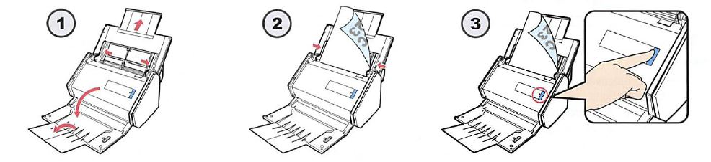

Start scanning documents and photos with the Fujitsu Scansnap iX500
1: Spread the paper guide all the way to the edges of the page feeder if they are not already there.
2: Place documents or photos in the page feeder. A very helpful hint is to place the documents so the back of the page is facing you and upside down in the page feeder, this will save you some work after the pages are scanned.
3: Move the paper guide to fit snuggly next to the paper in the tray.
4: Press the Scan button on the Fujitsu ScanSnap iX500 (it should be lit in blue)
5: The documents or photos will start scanning.
While the documents or photos are scanning a window will appear on the laptop.
When the documents or photos are finished scanning an "All Applications" window appears on the screen of the laptop.
Here is where you choose what kind of file your document or photo will save as.

Documents to PDF
If you have a document and you want to save it as a PDF click on "Scan to Folder"
The "Scan to Folder" window appears and gives you some options.
1: File Name; this allows you to name your PDF. The default name is todays date and a sequential number.
2: Save in; this gives you the option to choose where to save the file to. The default is to the documents folder on the desktop.
3: Click Save to save the document(s). Click "OK" when the "files were saved successfully." message appears.
4: Open the "Documents-Shortcut" on the desktop and you should see a PDF with the file name given to your scan.

Photos to image file
If you have a photo and want to save it as an image file click on "Scan to Picture Folder"
The "Scan to Picture Folder" window appears and gives you some options.
1: File Name; this allows you to name you photos. The default name is todays date and a sequential number.
2: Save in; this gives you the option to choose where to save the file to. The default is the pictures folder on the desktop.
3: Click Save to save the picture(s). Click "OK" when the "Files were saved successfully." message appears.
4: Open the "Pictures-Shortcut" on the desktop and open the ScanSnap folder. You will see all of your photos that you scanned. You will also notice you have the front and back of every picture. If the scanner didn't detect any writing on the back of a photo it might not include it in the folder.

Troubleshooting
If you encounter a jam a message will appear on the screen of the laptop. Open the scanner by pulling on the little button above the blue light towards you.
Once the lid is open you will be able to remove the document or photo that caused the jam. Close the cover; reinsert the document of photo that caused the jam and try scanning again by clicking on "Continue Scanning" on the screen.

Tips
To save time scanning, sort all of your photos by size before scanning.
Remember to place the document or photo backwards and upside down to save you from having to rotate them later.

