The “Session Information Bar”
The MyPC Session Information Bar displays at the top of the screen. It shows the remaining time and offers menu options to end or lock the session. Messages for the user will display under the session information bar.
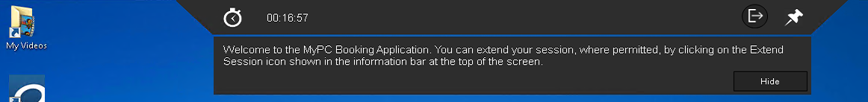
If you click on “Hide,” the session information bar will minimize itself and look like this:
Close-up with labels:
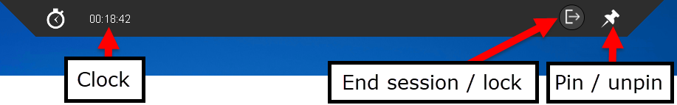

Pin/Unpin
- If you “pin” the session bar, it will remain displayed at the top of the screen and will not minimize.
- If you “unpin” the session bar, it will minimize itself. Click on the minimized bar to make it reappear.

End Session/Lock
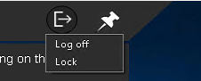
- After clicking the End Session/Lock button, you may “Log off” or “Lock” the computer.
- A “Log off” will log the patron out of the session and reboot the PC. “Lock” will keep the session active, but only the current patron can resume the session by entering his/her barcode and PIN.

Messages to the PC
Messages to the PC will display under the information bar
