Zoho Assist: Basics and Voice Chat
Sign in to Zoho Assist at assist.zoho.com. (Contact SCLS Help Desk if you need to create a login.)
Click on the “Unattended Access Tab” and find the name of the computer that you need remote access to. Choose “Connect” or “Join.”
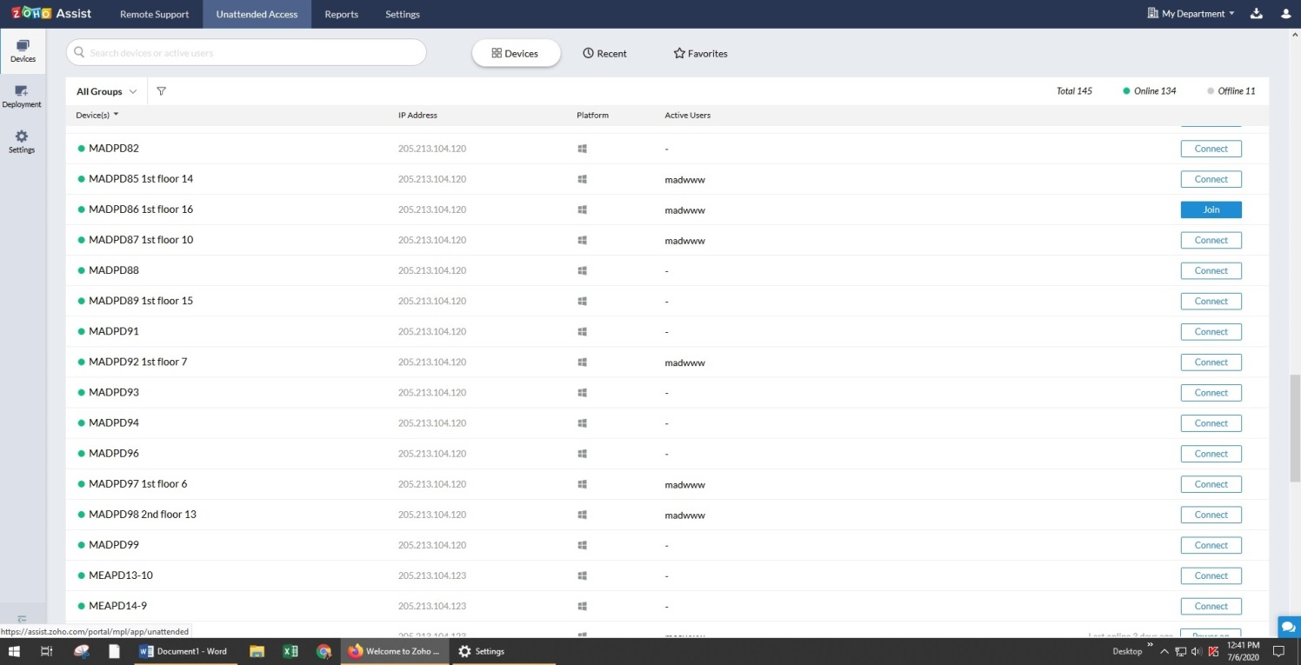
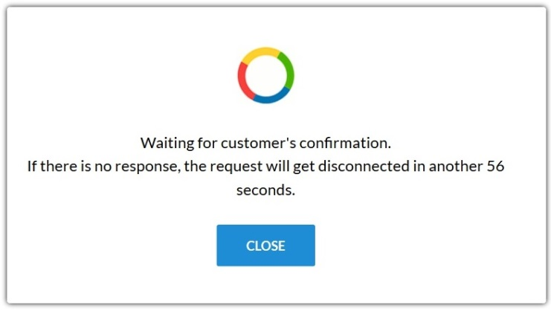
You will see the prompt “Waiting for customer’s confirmation. The patron will receive a message that reads “Allow ___ to control Desktop.” They will select “Yes.”

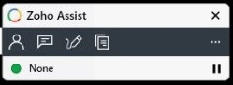
You now have remote access to the patron’s computer, can see the entire desktop and control the mouse cursor. Additional options for image selection, text chat, and document sharing can be found in the Zoho Assist toolbar located at the bottom right.

To facilitate voice chat, you will need a headset (for staff) and a desktop mic (for patrons). The patron will also need a pair of headphones or earbuds – their own or provided by staff. The desktop mic is ready to go once the USB is plugged into the patron’s computer. Headphones are not. The patron will see a prompt inquiring “which device did you plug in?” and “Headphones” must be selected.
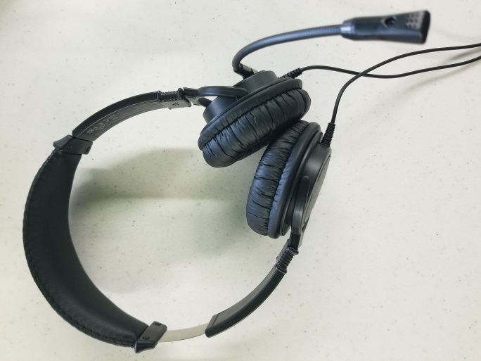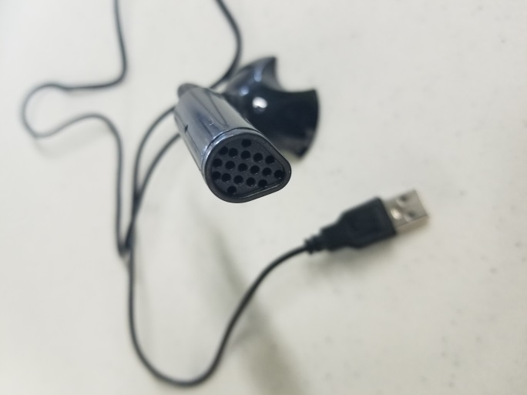

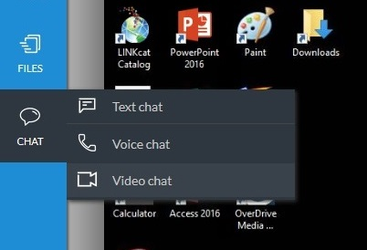
You will then select “Voice chat” in the left column. The patron will receive a message asking them to join.
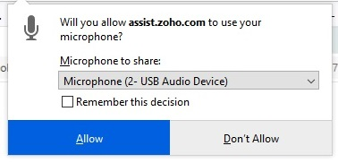

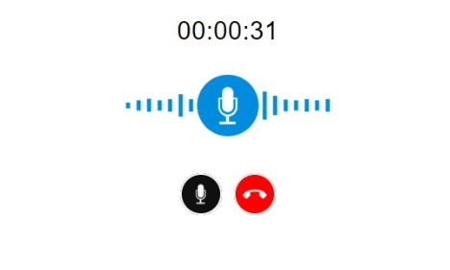
Having already plugged the headset into the USB port, you will also need to allow Zoho to use your microphone. A message will appear. Select the microphone to share and “Allow.”
When you see the image to the right, you are both connected and voice chat is enabled.

