Packing the VR Kit 1
Please follow these instructions for packing the VR kit in preparation for delivery to pick it up or to store before or after using. This will help insure the kit doesn’t break and can be used by all libraries in our system without damages incurring.
- Gather all the cables, camera and camera stand and find the box labeled, ‘Cables and Camera’. Wrap each cable into a circle and place in the box
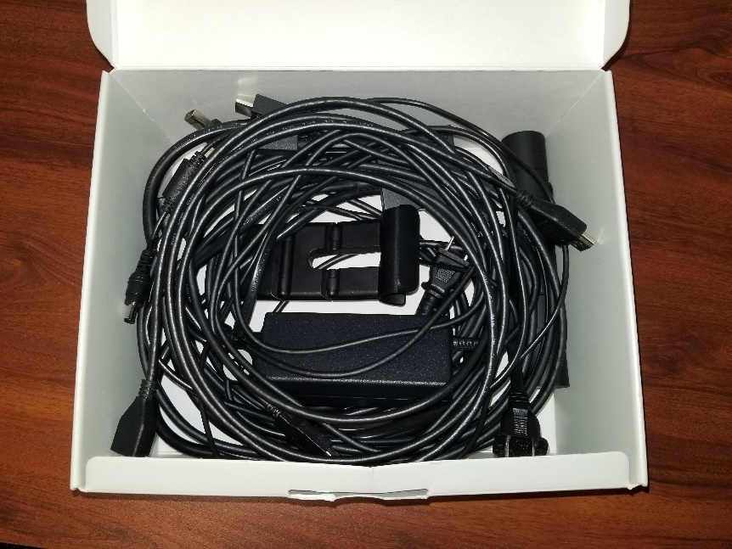

- Place the VR headset in the ‘VR headset Box’ making sure the front mask is all the way in and the cord can be placed inside the space for your head.

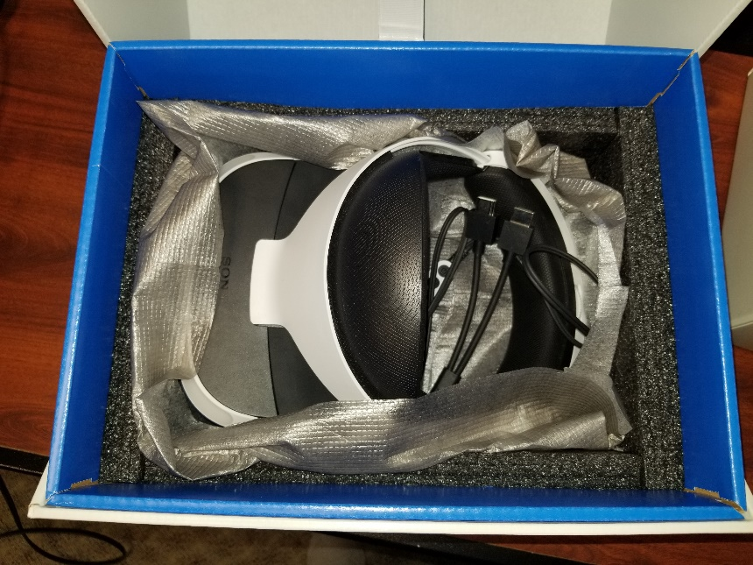

- Next grab the small blue box labeled, ‘VR Processing Unit’ and you will notice 2 pieces of foam within that box. Place the VR Processing Unit in the middle so there is a piece of foam on each side.
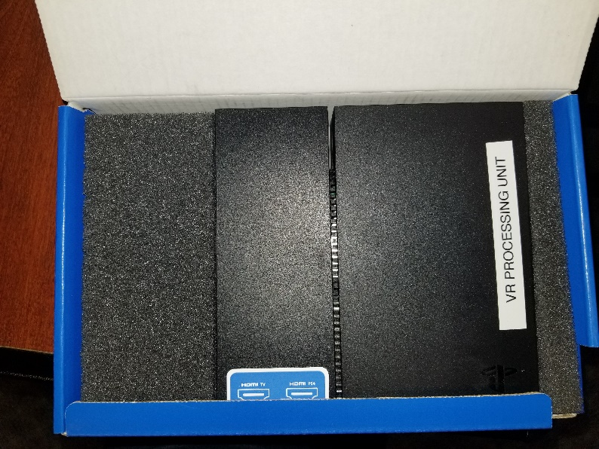

- The bottom of the grey bin has some foam to cushion everything and protect the PlayStation. There is a square cut out for the PlayStation console, place that in first. To the left of the PlayStation place the VR headset box in the top left corner.

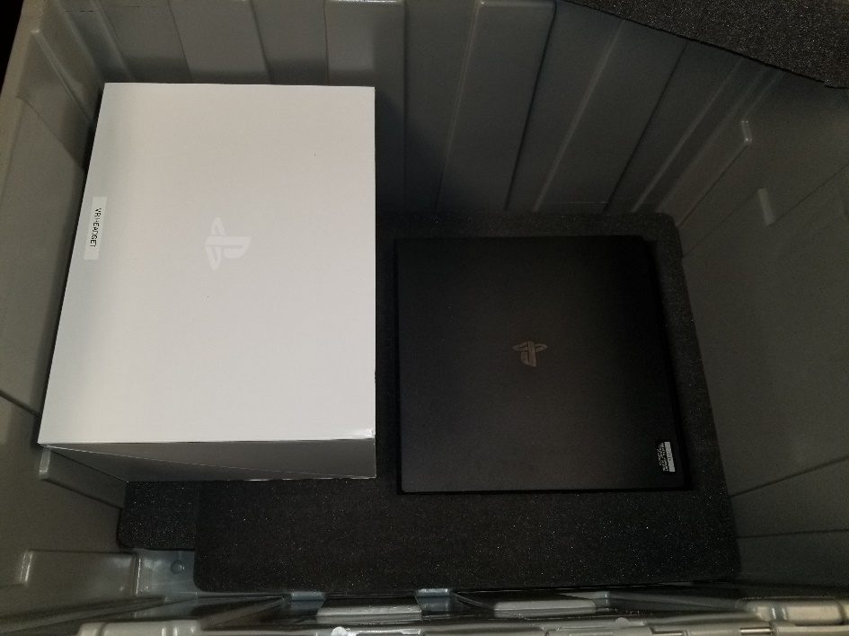

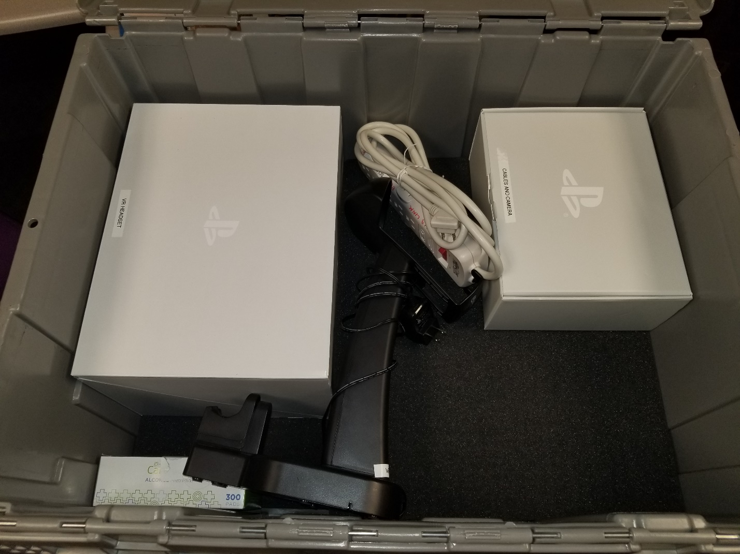
- Next, place the second piece of loose foam directly on top of the PlayStation. Set the box of Cable and Camera in the top right corner above the PlayStation. Set the box of alcohol wipes in the bottom left corner. Grab the VR Charging base and position it so it sits just below the VR Headset box and hugs the right side. Place the power strip between the cables and camera box and charging base.

- Place the VR Processing Unit box on top of the cable box. Grab the last piece of foam with the center cut out and place the 3 controllers inside. Place it in the bottom right corner.

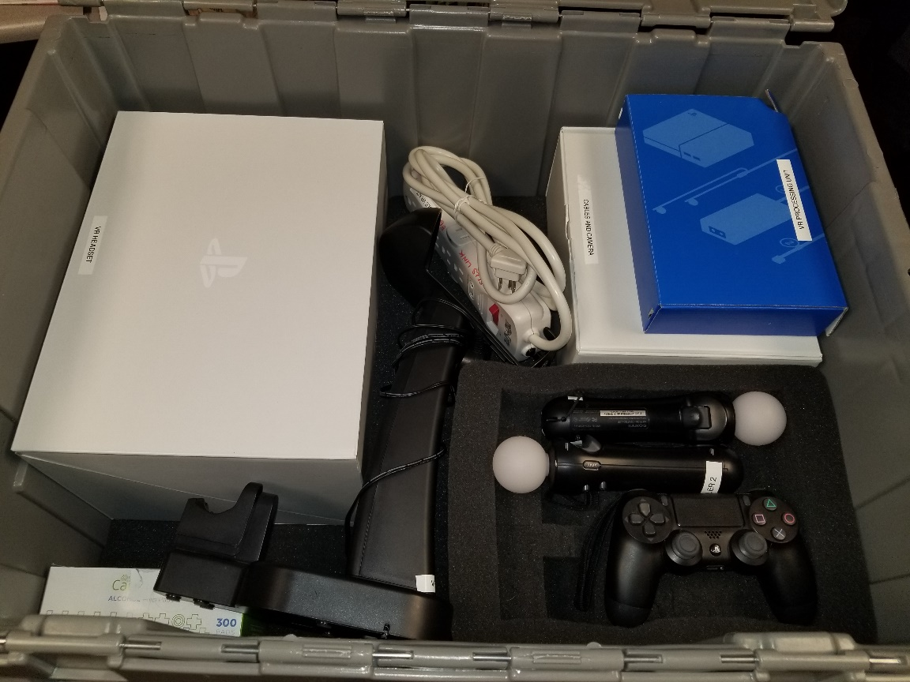

Ready for delivery!

