PlayStation 4 with VR Set-up Kit 2

VR Headset Stand and Charging Base
The first thing you will want to set up is the VR headset stand and charging base. You will want to do this first so the controllers will have time to charge. Plug the Power strip included in the kit into a wall outlet close to the TV. Then plug the base into the power strip and set the base where it will not be easily bumped or knocked down. Place the two handheld Move controllers side-by-side in the base and push down until the light comes on in the front. Next place the DualShock controller in front of the Move controllers and press down to lock it in place.
Next take the VR headset out of the box and place on the top of the base. Make sure the sides are all the way in adjusted so it will not slip and fall down. You should always keep the headset on the base unless someone is directly using the unit.

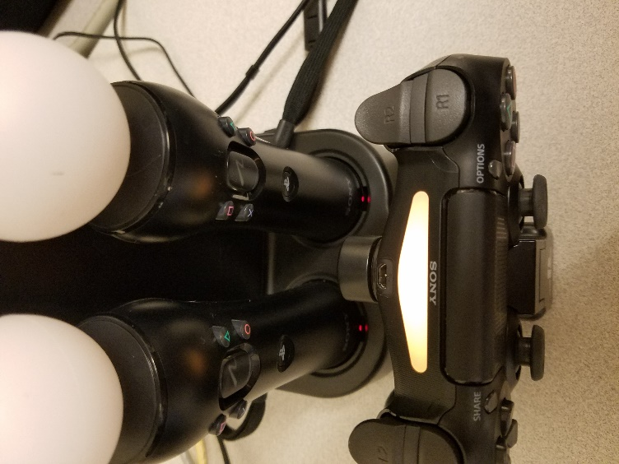
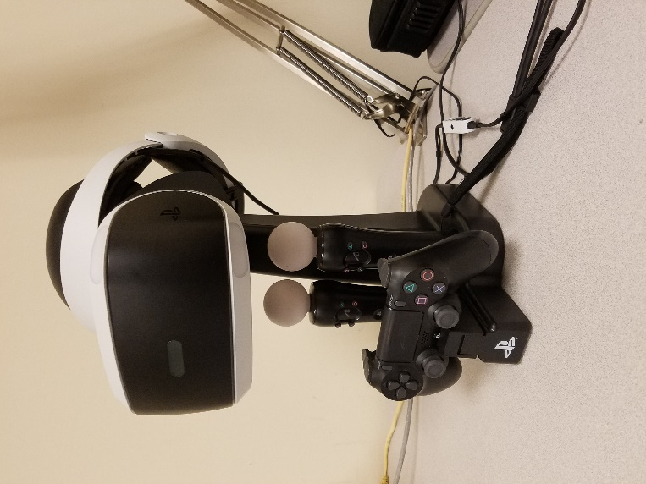

PlayStation
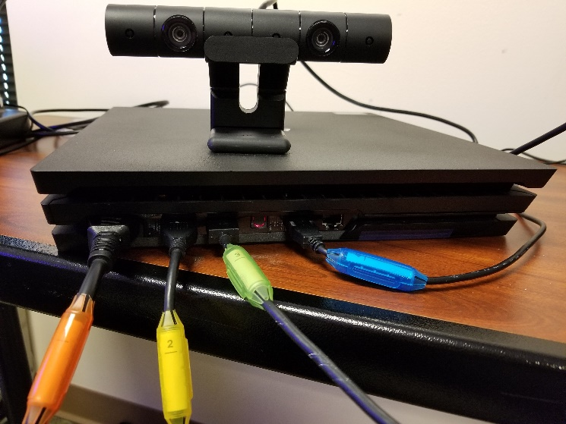
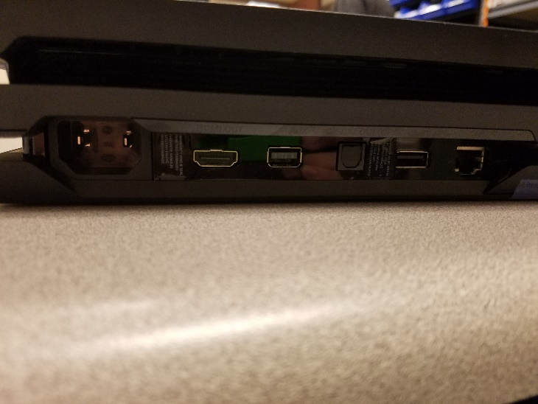
Set the PlayStation on a table next to the TV you will be using but with enough air flow so it doesn’t over heat. Plug in the cables from left to right starting with the power adapter 1 - Orange. Plug in the power adapter from the PS4 to the power strip. Next plug in cable 2 - Yellow which is an HDMI cable to the next spot on the PS4. Next plug in the camera which is cable 3 – Green. The camera also has a little stand you should place it in to help position it. Positon the camera to cover the area you will be playing in. Make sure it’s not too close or far from the space. Finally plug in cable 4 - Blue the USB end into the second to last spot. The last spot is not used.

VR Processing Unit
The last piece is the VR Processing unit. This will have multiple cables on all sides. It’s best to place this next to or near the PS4 but close to the space where you will be wearing the headset. Starting on the side with the most ports, plug HMDI cable 5 - Clear from the processing unit (HDMI TV) to the HDMI port on the back on your TV or projector. Next plug the free end HDMI cable 2 - Yellow from the PS4 to the processing unit (HDMI PS4). Next plug in the free end of cable 4 - Blue to the micro USB port on the unit. Next plug in cable 6 - Grey the power adapter to the back of the unit and the power strip. Finally grab the VR headset with cable 7 - Green attached and plug into the back of the unit lining up the triangle, circle, X and square from the ends of the cable to the symbols on the unit..

NOTE: After these steps you should be left with a cord in the box labeled 8 - Orange. This is OK and it is not plugged into anything yet.

