PlayStation VR Play Instructions

Do not play the VR alone. Have somebody with you to watch the cords so you don’t break the equipment and to watch you so you do not hurt yourself or others. Take breaks often as you may get motion sickness.

Getting to know the VR Headset
The VR headset should always be placed on the charging base and stand when not in use. The headset has a small set of controls on the cable to control sound and turn the unit on and off. There is also a headphone jack on the side for patrons to plug in their own headphones to make the VR experience better.
The headset will adjust for each user. Pull the back of the headset out by pushing the white button on the back of the unit and place it over your head. The unit will automatically retract to fit against the back of your head. If you feel it needs to be tighter you can adjust the white gear above or below the white button on the back. Next you can adjust the front by pressing the black button on the front of the headset under the face mask and pushing the mask in or out. When adjusting the headset make sure you are comfortable and no light is coming inside the mask. Make sure the cable attached to the headset is coming down and resting on your right shoulder in front of your body. You should be able to use with your glasses if applicable but DO NOT have your glasses lenses touching the VR lenses. .
To remove the head set press the black button under the face mask and pull the mask out. Then press the white button on the back and pull backwards while lifting off your head.
To clean the headset use the included microfiber cloth for the inside lenses. DO NOT use any liquid or other cleaners for the lenses!!!! Use the included alcohol wipes for the black foam pieces surrounding the head directly. Do not use these anywhere else.

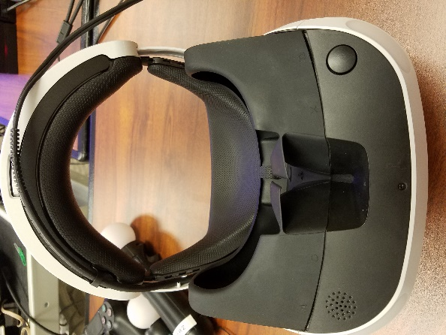

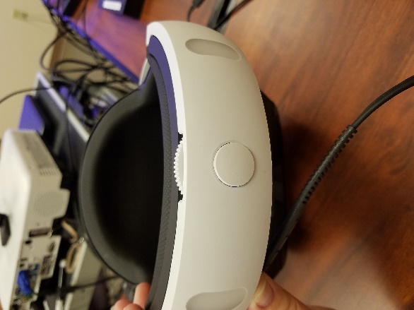
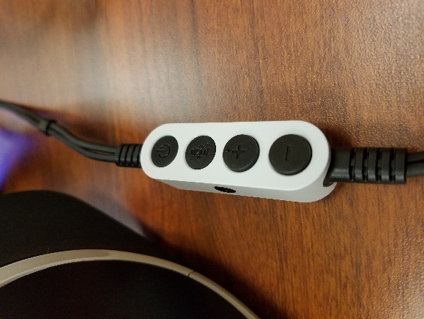

Getting Ready to Play
Once you have everything connected and set up it’s time to turn on the PS4. Leave your headset off for this part. Press the power button on the front of the PS4 or the PlayStation logo on the controller between the joysticks. The PS4 will now boot into the main desktop. Before choosing a game you should connect the Move controllers as well. One at a time, press the PlayStation logo and select the SCLS_VR on each controller.
You are now ready to select the game you wish to play. Some games use different controllers or no controllers. See below for game list.
After you select your game you will need to turn on the VR headset when prompted on screen. Press the power button on the headset cable. After putting on the headset (Please see earlier instructions on how to adjust the headset) you will need to set up the camera. The screen will walkthrough how to position yourself but just make sure you have plenty of room on all sides as you may be turning around. The screen will then flash off for a couple seconds and the blue lights will light up the headset.

Games Available to Play
We have downloaded a couple games to play as well as YouTube. You will not be able to download any other games yourself or access the internet. If there is a VR game you think we should add please send Emily an email at ewaring@scls.info to make a request.
HOMESTAR VR: View the night sky and check out the constellations with the DualShock Controller.
Beat Saber: Imagine if Dance Dance Revolution and Fruit Ninja combined with light sabers: That’s what this game is like. From Easy to Expert+ anyone can play this super fun game with the Move controllers.
Titanic VR: Explore the legendary ship in a submarine. Go on a tour or collect items with the DualShock Controller.
Eagle Flight: Become an eagle and soar through the city of Paris. Using the DualShock Controller you can fly anywhere in this game.
Keep Talking and Nobody Explodes: A great team game to work on communication and help each other diffuse the bomb.
The Playroom VR: Almost like Super Mario, but in 3D. Using the DualShock Controller, you collect the robots while moving through the virtual world.
The Last Guardian VR Demo: This is a good demo for someone who hasn’t used VR before. It’s a short demo featured a giant winged creature, heights, and easy controls with the DualShock Controller.
Discovery: A simple version of Minecraft. Use the Move controllers or the DualShock controller to build a world.
Job Simulator: A good game to get a feel for interacting with VR. Simulating different places of occupation you can control the world around you with the Move controllers with no rules.
VRog: Become a frog and hop from lily pad to lily pad eating bugs. This game is simple and only requires the headset to use.
Tiny Trax: Using the DualShock controller you race tiny cars around different tracks. Think of it as hot wheels but cooler.
Carnival Games VR: This game uses the Move controllers. Play classic carnival games to earn tickets for prizes!
Youtube: YouTube is located under the TV & Video folder. To access YouTube you will need to connect to the Wi-Fi to Library-Wireless. To do this, open the settings on the top menu bar.
Click Network > Set up an Internet Connection > Use Wi-Fi > Easy > Library-Wireless > Test Internet Connection. After test completes press the PlayStation logo button to return to the main screen.

Troubleshooting:
The controllers will not connect to the PlayStation.
- Plug cable 9 - Orange into the move controllers and press the PlayStation logo on the controller. You can unplug it once you select the SCLS_VR profile.
- Plug cable 8 - Grey into the DualShock controller and press the PlayStation logo on the controller. You can unplug it once you select the SCLS_VR profile.
After starting a game the camera seems off or not positioned correctly.
- Unfortunately this does happen from time to time or if switching with users with different heights. Press and hold the PlayStation logo button once again until the menu comes up. Select close application. Reopen the game again.
The camera is not cooperating.
- Sometimes, depending on the surface, the camera will not stay in one place or is too low. If the camera is not staying in one place you might need to get creative on a way to secure it to the surface it’s on. Try placing some heavy books on either side of the camera stand to “hold” it in place or using a small amount of tape on the stand only.
- You can place the camera on a box or stack of books to adjust the height better.

