Person-in-Environment Worksheet

Individual or group for PIE:
 | Micro Level | Mezzo Level | Macro Level
What are some possible influences on this individual or group?

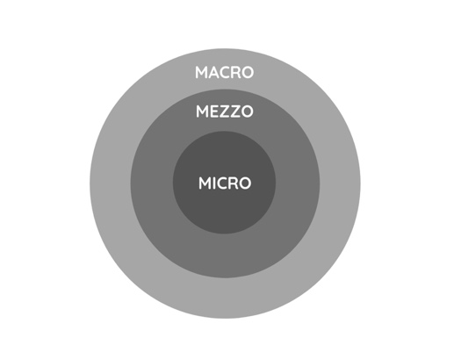
What are some interventions the library can offer in response to these influences?

Boundaries!

Think about boundaries. Which parts of this are yours to address, and which parts should be addressed by others?

