Sphero, what’s in the box!
This is a picture guide showing what’s in the Sphero cases.
The first picture shows how to package the Spheros when you are done playing with them.
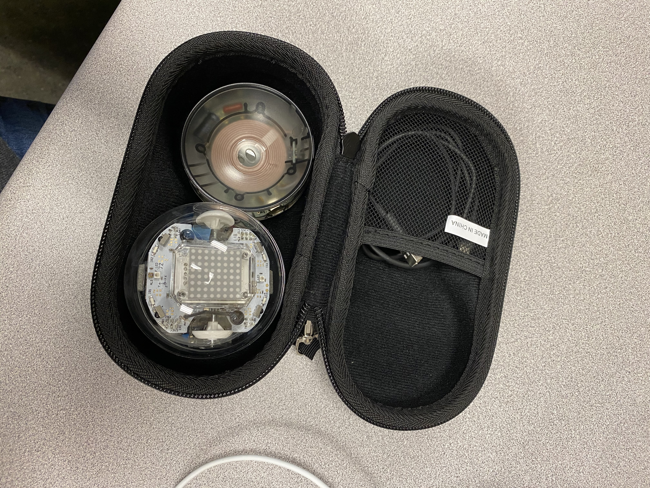The second picture shows how to correctly charge each Sphero.

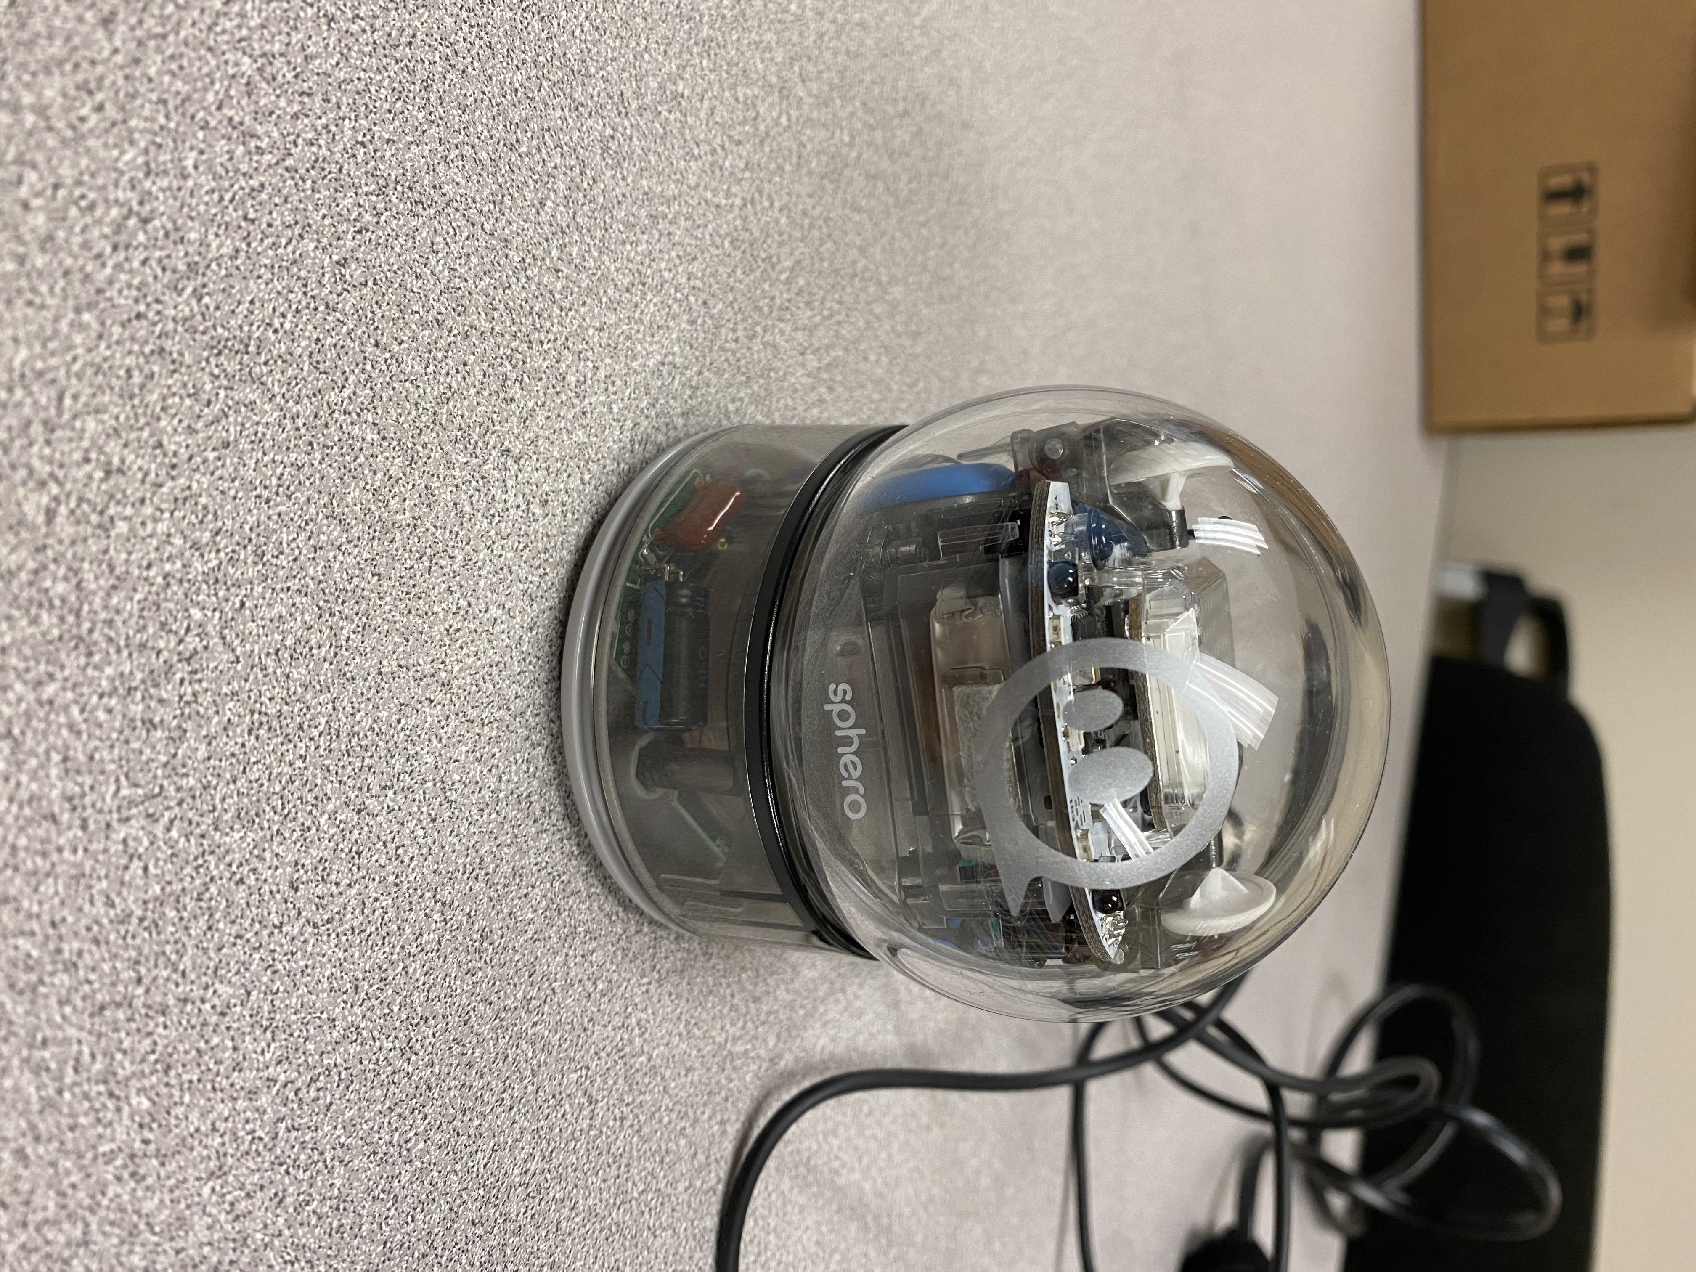

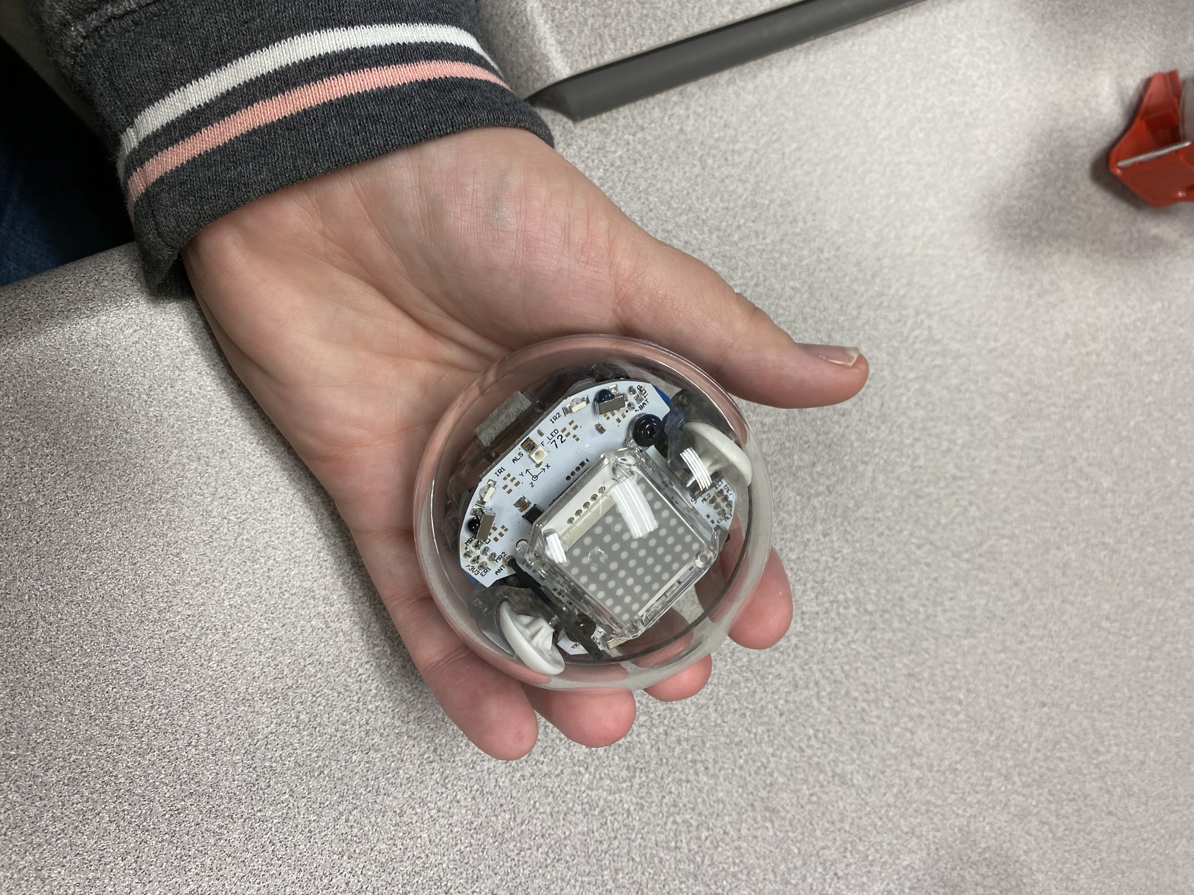

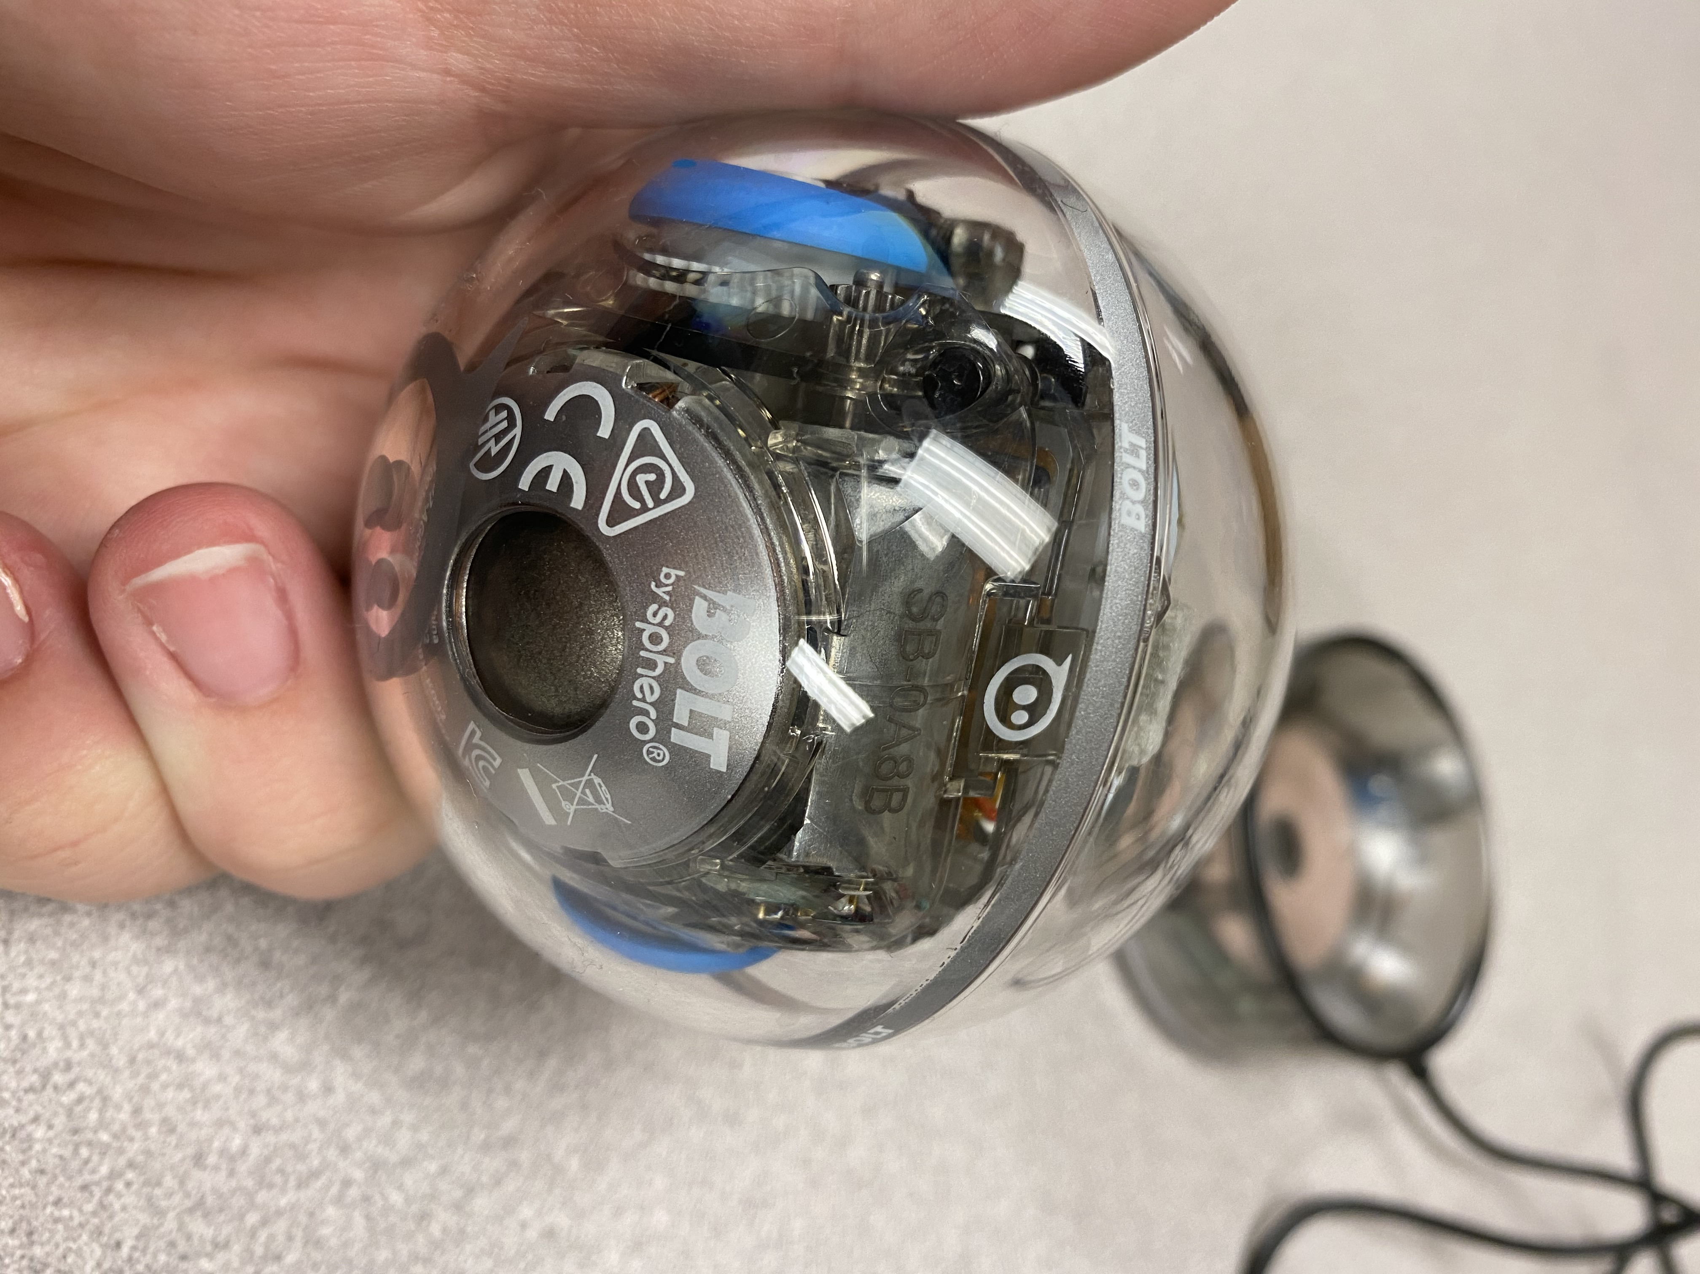

This picture shows the unique name of the Sphero. In this example it’s: SB-0A8B
This is used to connect the iPad to the Sphero.

