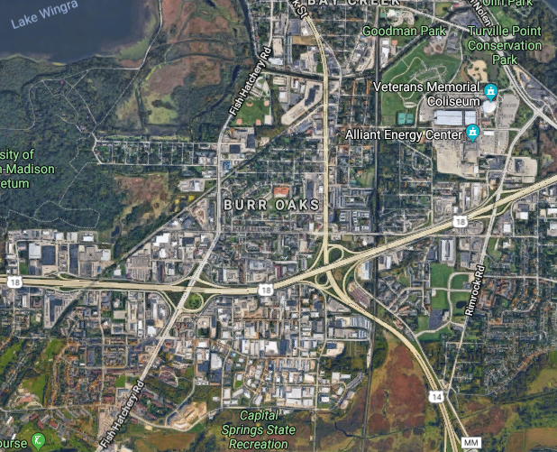
South Madison:
- Delivery Route System essentially the same
- Property value likely reasonable
- Largely built out; existing buildings may be the market
- Susceptible to Beltline congestion periods
- Appears to have possible connections to MUFN
- Bus routes on Fish Hatchery but not within the territory East of FHR and west of Park Street/Highway 14

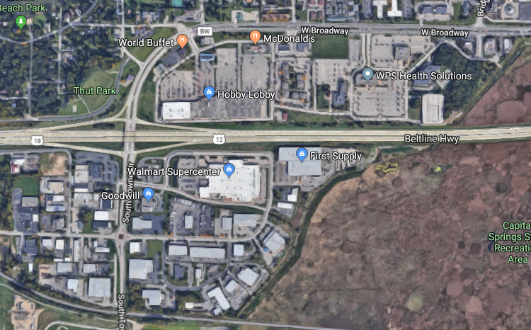
Monona:
- Similar route structure
- Susceptible to Beltline congestion periods
- Bus route dissects the area on South Towne and Broadway
- Property values likely reasonable
- Area is built out; Existing buildings

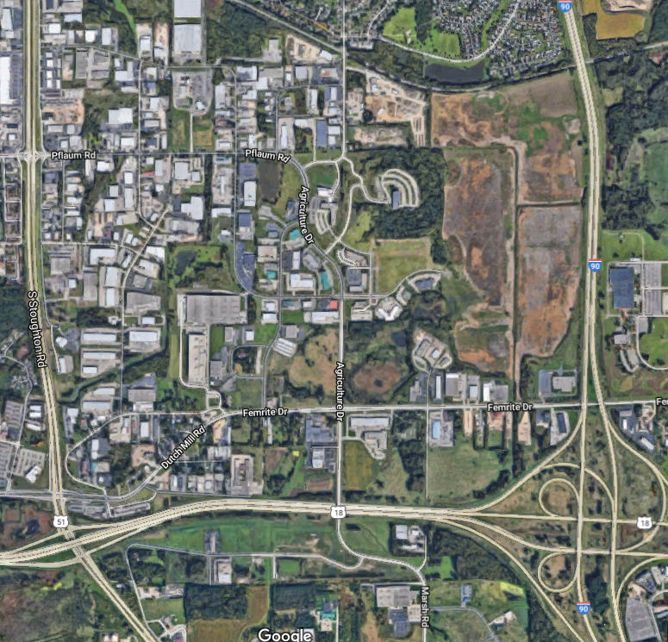
Southeast Madison:
- Some vacant space
- Bus lines on Agriculture, World Dairy, and Pflaum
- Access to Beltline is good; Congestion is less of an impact. To the Interstate is a bit longer but better than current south-side location.
- Property values are higher, but this is largely and office-park style area
- MUFN has some extensions here.
- Landfill complaints have been noted from residents to the north.

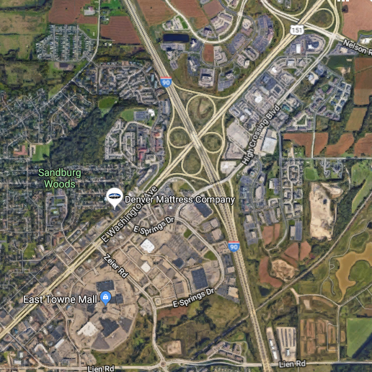
East Towne Area:
- Potentially available vacant retail buildings (Menards)
- Bus lines
- Easy access to north, south, and east.
- Stretching away from downtown and west side (as well as southwestern routes)
- Property values are probably higher; Renting might be the only plausible option in this area of high retail.
- Short move for Admin
- MUFN in the area

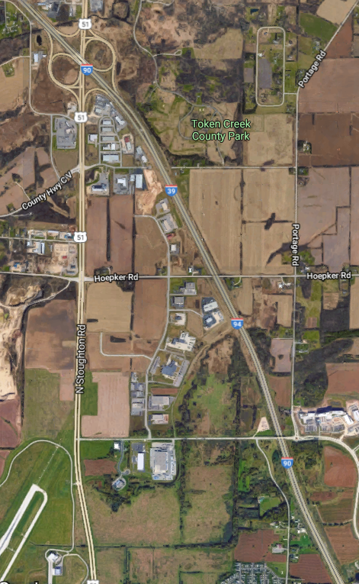
Airport (West of Interstate):
- Newly developed industrial park
- Property values probably higher.
- Limited to no bus service at this time
- No MUFN nearby at this time
- Great access to Interstate and points north and east
- Stretched further from West-side and downtown locations.

Areas that appear to be a significant net-negative:

West Side and Middleton:
- A lot of the negatives of stretching further away from center without the access to the interstate
- Bus lines and MUFN have limitations

Sun Prairie, DeForest, Verona
- Really stretching the time to downtown and campus
- No bus and no MUFN

