Workflow for creating Local Hold/Use item records
Pilot project July 1-December 31, 2022.

Steps for creating items with Local Hold/Use parameters
Use the searching/matching and linking instructions in the Linking Manual, Section V Books to add an item to an existing Bibliographic record or follow the steps to create a BSE for the title (Part 6)

When you find the correct/matching BIB record, link your item to the record (Linking Manual, Section XII Linking items) and assign these parameters in the item record:
Item Type = BKALH14
Shelving Location = (indicates new item?)
Collection code = BKAFI or any other BKAFI collection code
STAFF NOTE = “2022 JULY NEW” – Optional. Only needed if running the On Demand report.
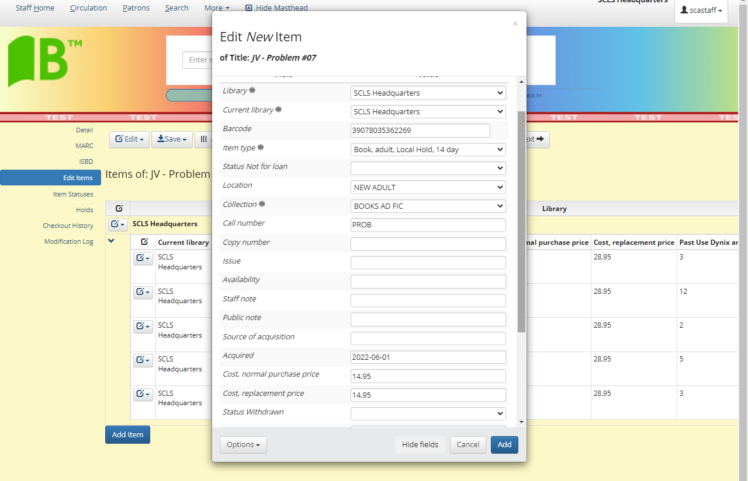

Add the item.
Then click on the Item Statuses link in the left menu bar.
In this screen, change the Custom Status field for this item to “Local Hold”

This item will have a status of Available AND a status of Local Hold. This will be part of the information to share with patrons – that if they see this combination of statuses in the catalog, this item is in-library and available for a walk-in checkout or to fill a local hold.

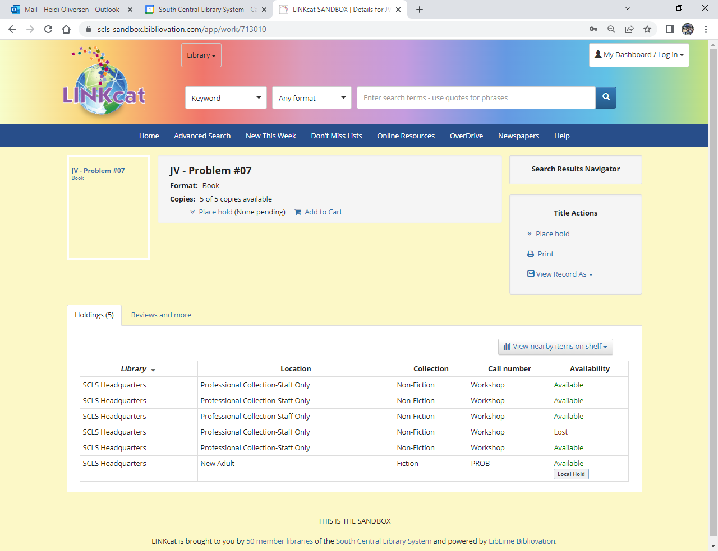

Finish processing the item with any labels to indicate New item or Local Hold item.

The Custom Item Status “Local Hold” will not be removed by Check Out or Check In.

Steps for removing Local Hold/Use item parameters

AFTER 60 DAYS, you will need to edit the item parameters to change the item to [normal] parameters.
Individual items
- Access the item record.
- Edit the item to change the Item Type to BKA14 or BKA28.
- If you added a Staff Note remove it
- Save the change.
- In the Item Statuses screen, click “X” at the end of the Local Hold status to remove it.
- Check in the item. It may be trapped to fill another hold at your library, a hold at another library or will remain at your library to be shelved.

Multiple items using Batch Item Edit
- Run the On Demand report Local Hold/Use items
  - Enter your library code
  - Enter the Staff note for the Month you are changing; e.g. “2022 JULY NEW”
- OR pull the materials from the shelf and scan the item barcodes into the Batch Item Editor.
- Add the item numbers to the Batch Item Editor (Linking Manual, Section XIV Editing, Moving and Deleting items, Part E Batch Edit of items
  - Change the Item Type
    - Field: Item type
    - Action: Set To
    - Value: Book, adult, 14 day loan (BKA14) or Book, adult, 28 day loan (BKA28)
  - Remove the Custom Item Status
    - Field: Custom Item Status
    - Action: Remove Status
    - Value: Local Hold
  - Remove the Staff Note (if used)
    - Field: Staff note
    - Action: Set NULL
    - Value: n/a
- Check in the items. Items may be trapped to fill another hold at your library, a hold at another library or will remain at your library to be shelved.

